**Module 2 Milestone**

Jesenia Roberts

Southern New Hampshire University

CS- 330

Professor Jeff Phillips

November, 4, 2023

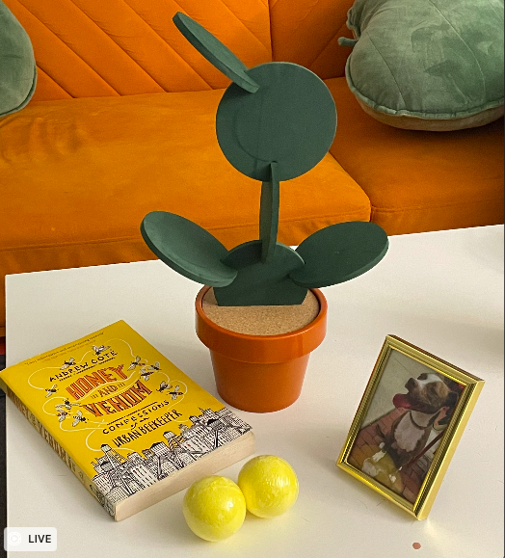

The objects I will be creating are the novelty cactus coaster, the picture frame, the book, and the two bath bombs. These items are good candidates for recreation because it is easy to see the primitive shapes that create them, while the cactus still provides a challenge due to the morphing of primitive shapes required to make it.

The primitive shapes I will be using to create these objects are a cube (in a rectangular shape) for the book, a plane for the picture frame, spheres for the bath bombs, a cylinder, torus, and circle planes for the coasters. Additionally, there will be a plane to ground all of these shapes and to mimic the coffee table that all of the objects are on.

This will make a good project for me to create as it combines fun items from my home that should be relatively simple to learn how to form in OpenGL. These items are easy to see the outline of on the white coffee table, and their bright vibrant colors also allow the individual shapes to be seen distinctly, and will additionally add visual interest to my project.